Dear Employees,

We are very excited to announce that you can choose to receive your W-2 electronically! An electronic version of your W-2 creates some great benefits which include:
- Earlier Access since you don’t need to wait until its printed and mailed.
- Significantly less possibility of your W-2 getting lost or misplaced.
- You can access it from anywhere (home or work) whenever you need it.
- Compensation and tax withholding information may be easily downloaded into many tax preparation software programs.
- Its COVID safe. Electronic access eliminates the handling of the W-2 throughout the generation and mailing process.
Sounds great, right! So how do you get started?
Simply login to your Employee Self Service portal at www.payservpayroll.com and
ensure that you have accepted Electronic Delivery of Tax Forms. By clicking “I Accept”,
you will be able to securely retrieve your W-2 any time you wish. You can look forward to an email in January letting you know that your W-2 is ready for download and you’ll have any previous year W-2s as well that can be accessed whenever you need them. See below for more details:
If you are having trouble logging in, please scroll to the bottom section titled “Login Issues”.
First Time logging in to Employee Self Service?
If this is your first time logging in to iSolved Employee Self Service (ESS), you will be
greeted with this message box below. By clicking “I Accept”, you will be able to access
your W-2 on your ESS portal and securely retrieve your W-2. You can look forward to an email in January letting you know that your W-2 is ready for download.

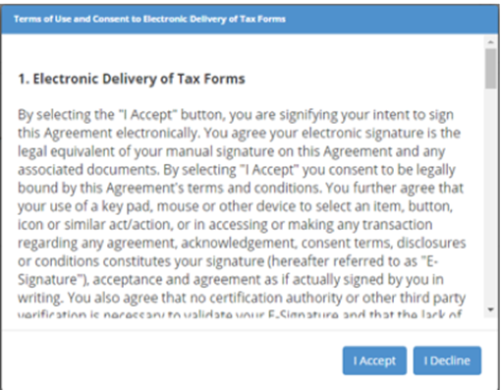
I Accept = Electronic W2.
I Decline = Paper W2. ☹

Why don’t see any message box when I login?
This means you must have already responded to the message box. If you don’t
remember what you chose, refer to the next question.
What if I don’t remember if I Accepted or Declined?
Don’t worry! I don’t remember what I ate for lunch yesterday. You can double check by
logging in to your employee portal, click on your name in the top left of your screen and
choose “Electronic Delivery – Tax Forms”.
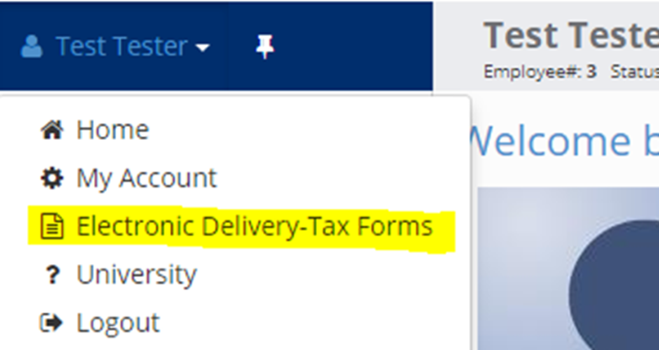

When you click on Electronic Delivery-Tax Forms, you will see one of two messages:
If you originally clicked Accept, the system will tell you that “You have already agreed…”

If you see this message box, you will not receive a paper W-2. Instead, you can look
forward to an email in January letting you know that your electronic W-2 is ready for
download.
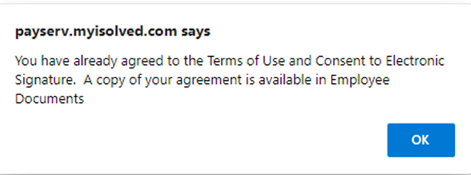

If you originally clicked Decline, the initial message box will appear again. You can now
choose to Accept or Decline. Remember, by clicking Accept, you will receive an
electronic W-2.
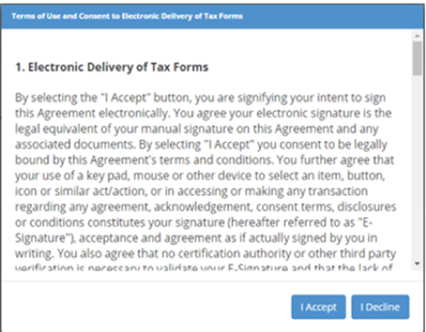

I originally Declined, but now I want to change and receive an electronic W-2.
Easy …just like in the question above, you will login to your iSolved portal, click on
“Electronic Delivery-Tax Forms” and the original message box will reappear. You can
now choose to Accept.
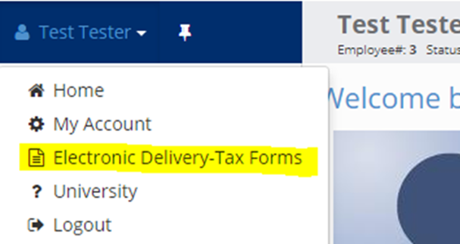

I originally Accepted, but now I want to Decline and receive a paper W-2.
For this, you will need to contact your payroll administrator; only they can withdraw
your original consent. To do this, they will go to Employee Maintenance>General and
enter a date in the “YE Consent Withdrawn” field.

Does this also apply to 1099 and ACA 1095 Forms in addition to W-2s?
Yes, the electronic consent is for all three year-end forms if you have them: W-2, 1099,
and 1095

Login Issues
I’ve previously logged in, but I forgot my username.
Your username is your work email address. If you do not know the exact email address,
contact your payroll admin for this information.

I’ve previously logged in, but I forgot my password.
You have 5 chances to get it correct. The system will then disable you for 10 minutes
before you can try again. If you need a new password, click the “Forgot Password” link.

I’m getting this message: “This user account is currently disabled. Please contact your
account administrator for assistance.”
If you have not logged in for 90 days or never activated the account to begin with, your
account may be disabled. You will need to contact your payroll admin and they can send a new activation email.
My payroll admin says they sent me an activation email, but I’m not getting it.
First, check your junk mail. The email would be sent from no-reply@Infinisource.com. If
you do not see it, check with the payroll admin to ensure they are using the correct email address.

